Abstract

Robust decisions under risk & uncertainty
In order to learn Decision Maker’s (DM) preferences and make robust decisions under risk and uncertainty, we apply Robust Ordinal Regression (ROR). This technique was originally proposed for multiple criteria decision aiding (MCDA) with the aim of taking into account the whole set of instances of a chosen type of preference model, which are compatible with preference information supplied by the DM in terms of holistic preference comparisons of some alternatives. ROR yields two weak preference relations, necessary and possible, in the whole set of alternatives; the necessary weak preference relation holds if an alternative is at least as good as another one for all instances compatible with the DM’s preference information, while the possible weak preference relation holds if an alternative is at least as good as another one for at least one compatible instance. To apply ROR to decision under risk and uncertainty we reformulate this problem in terms of MCDA. This is obtained by replacing an uncertain outcome of a decision problem on a set of alternatives (e.g., a gain on investment) by a set of quantiles of the outcome distribution, which are meaningful for the DM. These quantiles become evaluation criteria of a deterministic MCDA problem, equivalent to the decision problem under risk and uncertainty. To solve the MCDA problem we apply a ROR method, like GRIP or ELECTRE-GKMS. We illustrate our proposal by solving an example of the famous newsvendor problem.

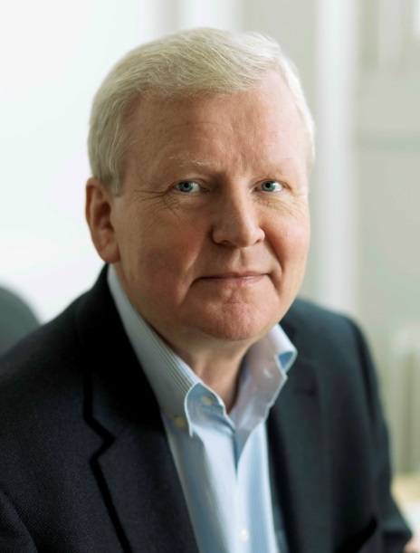
Roman Słowiński is a Professor and Founding Chair of the Laboratory of Intelligent Decision Support Systems at the Institute of Computing Science, Poznań University of Technology in Poland. Since 2002 he is also Professor at the Systems Research Institute of the Polish Academy of Sciences in Warsaw.
He is a full member of the Polish Academy of Sciences and, presently, elected president of the Poznań Branch of the Academy. He is also a member of Academia Europaea.
In his research, he combines Operations Research and Computational Intelligence. Today Roman Słowiński is renowned for his seminal research on using rough sets in decision analysis, and for his original contribution to preference modeling and learning in decision aiding.
He is recipient of the EURO Gold Medal, and Doctor Honoris Causa of Polytechnic Faculty of Mons, University Paris Dauphine, and Technical University of Crete. In 2005 he received the Annual Prize of the Foundation for Polish Science - regarded as the highest scientific honor awarded in Poland.
Since 1999, he is principal editor of the European Journal of Operational Research,
a premier journal in Operations Research. He is coordinator of the EURO Working Group on Multiple Criteria Decision Aiding, and past president of the International Rough Set Society.

Homepage: http://idss.cs.put.poznan.pl/site/rslowinski.html

